***Experiment 9***

**Aim:** Code Review Automation: Integrate a code quality analysis tool like CodeFactor or Codacy with GitHub to automatically analyze code changes and provide feedback on code style, complexity, and potential issues.

**Codacy:** Automating Python Code Review with Codacy

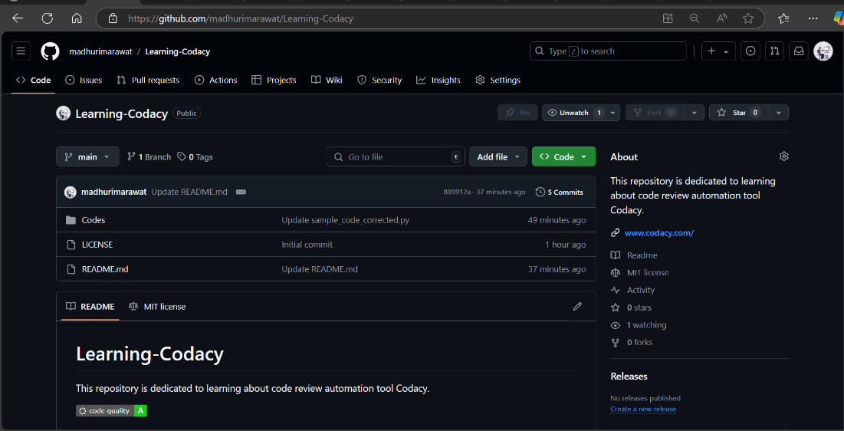

***Fig 1: Running Sphinx Commands***

***Fig 2: Output Sphinx Documentation***

**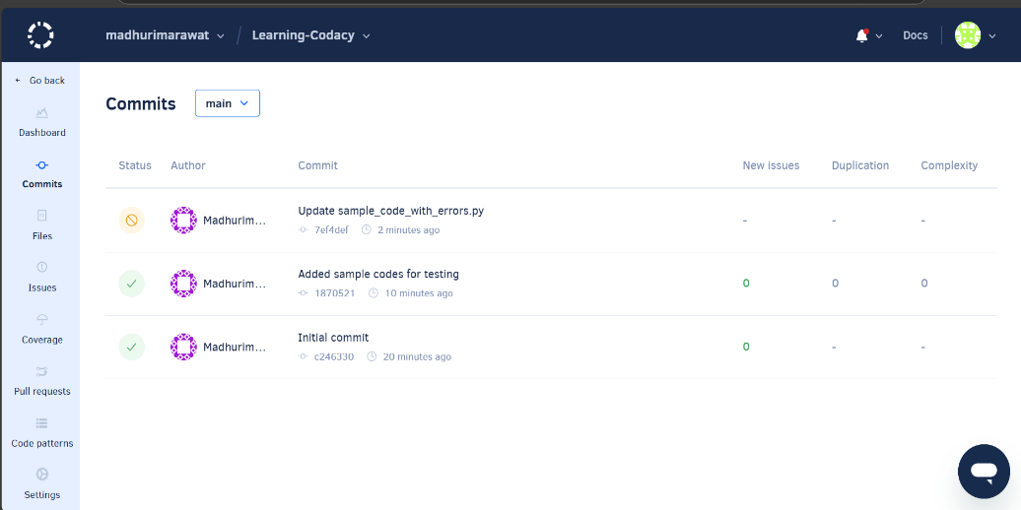*Fig 1: GitHub Repository with all the Files and Workflows***

***Fig 2: Outp***

***Fig 2: Codacy Dashboard with Error Workflows(Wrong Test Cases to observe workflow)***

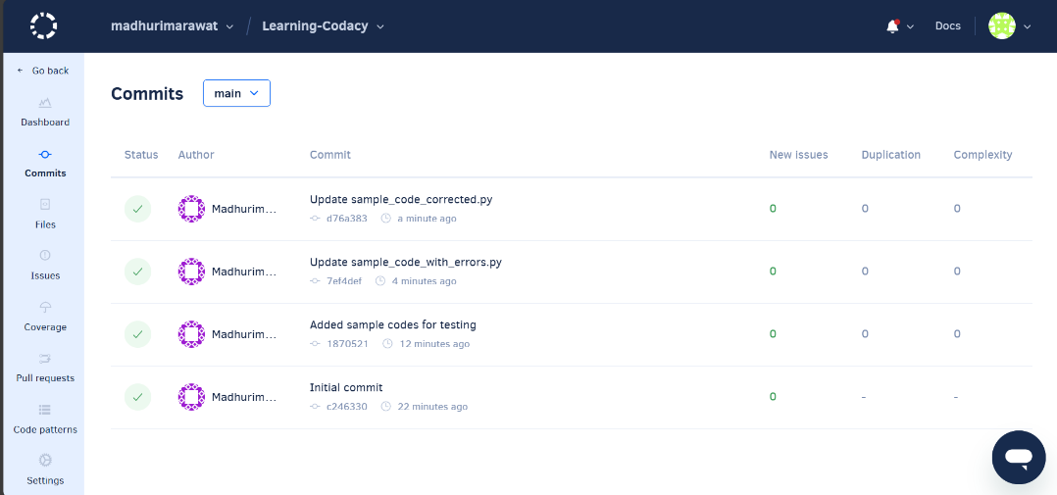

***Fig 3: Codacy Dashboard with Correct Workflows(Successful Test Cases)***

**CodeFactor:** Automating Python Code Review with CodeFactor

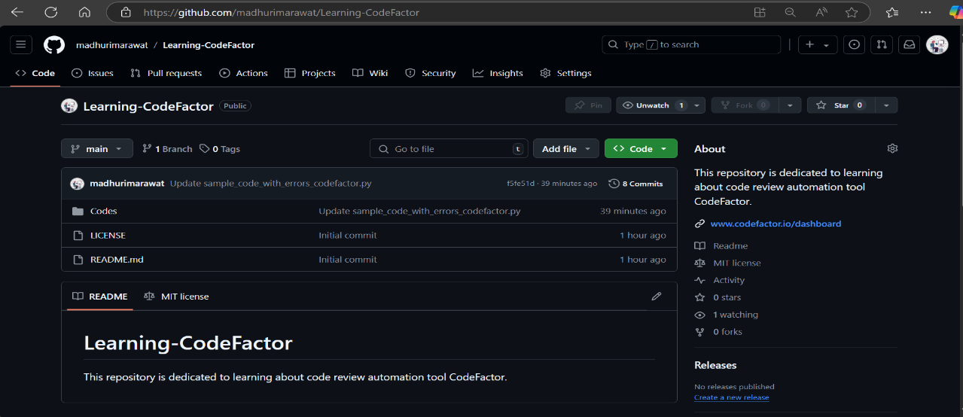

***Fig 4: GitHub Repository with all the Files and Workflows***

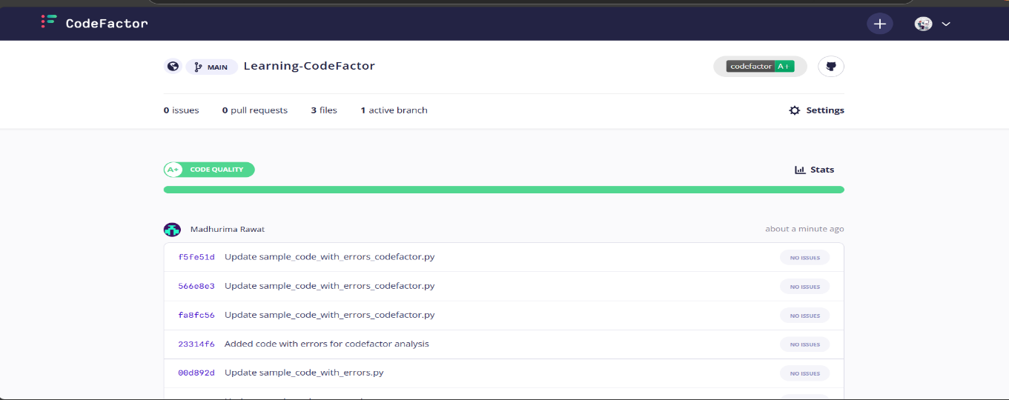

***Fig 5: CodeFactor Dashboard with Error Workflows(Wrong Test Cases to observe workflow)***

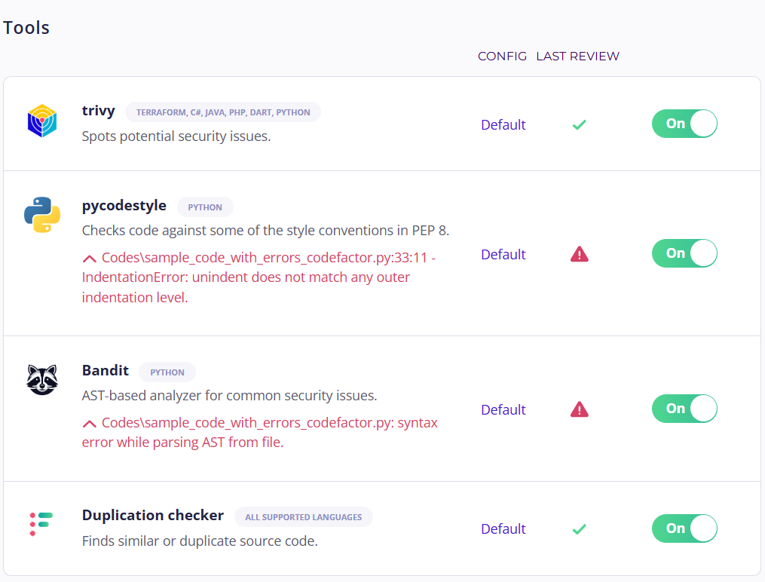

***Fig 6: CodeFactor Dashboard with Correct Workflows(Successful Test Cases)***